**Optimal Linear Quadratic Tracker for**

**Five-Degree-of-Freedom Active Magnetic Bearing System**

**Log 20151007**

The objective of this report is to show how our newly proposed approach outperforms the one presented in Literature [1].

[1] F.-J. Lin, S.-Y. Chen, and M.-S. Huang, “Intelligent double integral sliding-mode control for five-degree-of-freedom active magnetic bearing system,” *IET Control Theory and Applications*, vol. 5, no. 11, pp. 1287-1303, Appl., 2011.

1. **A novel optimal linear quadratic digital tracker for the discrete-time system with a direct-feedthrough term and known system disturbances**

A novel optimal LQDT with pre-specified measurement output and control input trajectories and its corresponding steady-state version for the discrete-time controllable, observable, and non-degenerate system with both an input-to-output direct-feedthrough term and known system disturbances are presented in this section.

Consider the controllable and observable linear discrete-time system with an input-to-output direct-feedthrough term and known/estimated system disturbances or compensatory signals  and 

 (1a)

 (1b)

where    and  are state, input, output, and direct-feedthrough matrices, respectively.  is the state vector,  is the control input, and  is the measurable output.The design goal is to determine the optimal control sequence      that minimizes the linear quadratic performance index for a finite time process

 ()

where  is a  positive definite or positive semi-definite real symmetric matrix,  is an  positive definite real symmetric matrix,  is a  positive definite or positive semi-definite real symmetric matrix,  is a pre-specified output trajectory, and  is a pre-specified input trajectory. Solving (2) yields to the continuous-time state-feedback control law as

 (3a)

where

 (3b)

 (3c)

 (3d)

 (3e)

 (3f)

 (3g)

 (3h)

 (3i)

and  satisfies the algebraic Riccati equation

 (4)

1. **Five-DOF AMB system**

* **Our newly proposed approach**

Assume the system state is measurable. Then, apply the control methodology mentioned in Sec. 1 to have a near perfect tracking performance shown as follows. Here, we only show Simulink models. As for the main source code can be referred to other attached file. Since the practical system state is not measurable, we will apply the observer/Kalman filter identification (OKID) method to construct a state estimator to realize the above-mentioned tracker in next step (to be continued later). Basically, the observer-based tracker will demonstrate a similar performance as the case presented.

**2-1. Mathematical modelling of the open-loop system**



Fig. 1 Structure of ﬁve-DOF AMB system [1]



Fig. 2 Drive system including DDM and power amplifiers of left RAMB [1]



Fig. 3 Geometry relationships of rotor and AMB systems [1]



,

, (Source: [1])

,

where



The following output equation is formulated by our self, since Lin et al. [1] ignored the fact that the bearings and sensors are non-collocated, i.e. their axes differ by a certain distance. Thus, [1] assumes  is measurable. However, it does not.

,

where  are positions of bearings A and B with respect to the center of gravity of the rotor, respectively, and  are positions of sensors A and B with respect to the center of gravity of the rotor, respectively,

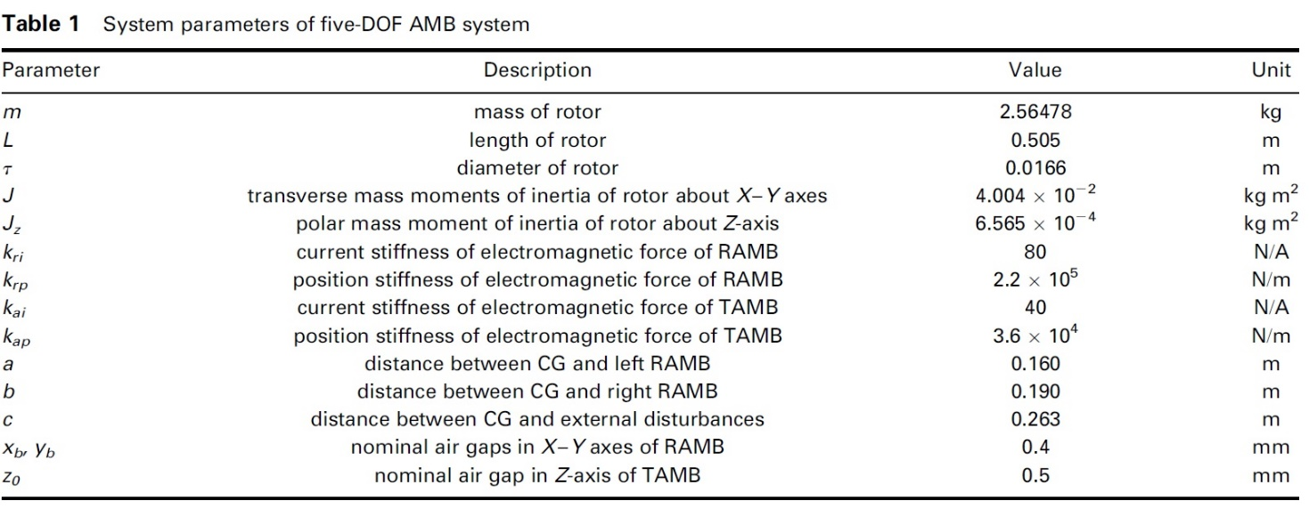

(Table source: [1])

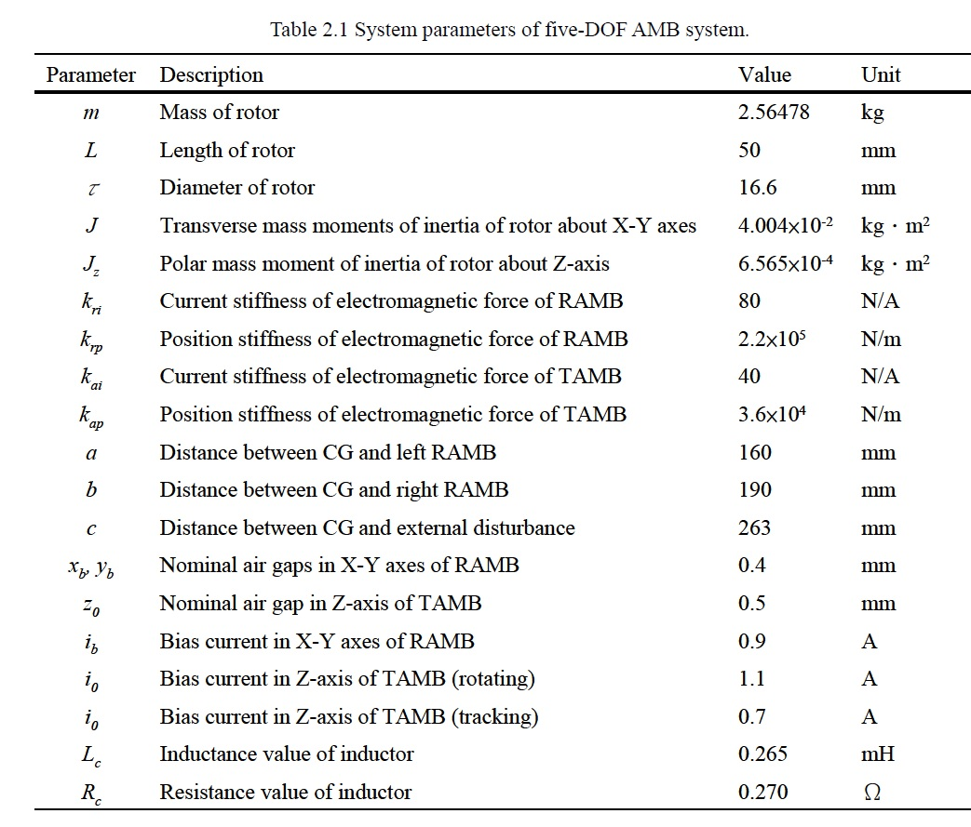

(Table source: [1])

|  |  |
| --- | --- |
|  |  |

Figure 4. Open-loop step response and pole zero mapping

Fig. 4 shows the open-loop system is highly unstable.

**2-2. Rotor orbit**

For comparison, we first show the simulation results presented in [1] as follows. Then, show our simulation results later.

* **Simulation results presented in [1]**



Fig. 5 Experimental results of ﬁve-DOF AMB control system using decentralized ISMC system at Case 1: a. Left rotor orbit, b. Right rotor orbit, c. Rotor position, d. Total currents in y1-axis,

e. Total currents in y2-axis, f. Total currents in z-axis (Figure source: [1])

* **Simulation results proposed by us**

Here, we only show Simulink models. As for the main source code can be referred to other attached file.

**Simulink models**

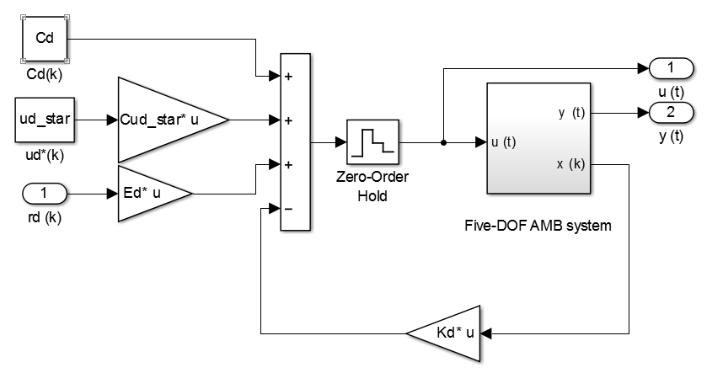

Figure 6. Closed-loop system

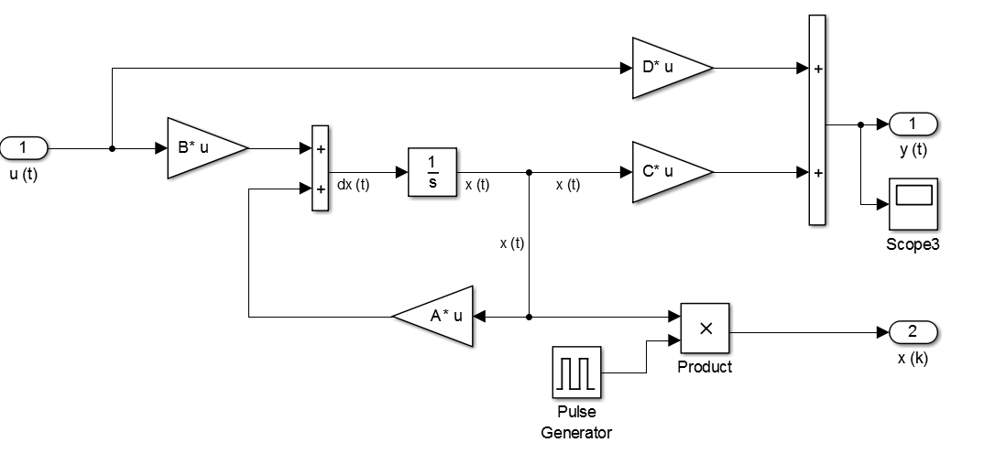

Figure 7. Plant diagram

**Closed-loop System**



Figure 8. Closed-loop pole-zero mapping



Figure 9. Rotor orbit via our proposed approach

Comparing [1] with our newly proposed approach, one can see that

1. Placements of bearings at A and B via [1] are uniformly distributed in some dicks, which are much bigger than our cases, where

Literature [1]:  and 

 and 

Our proposed approach:  and 

 and .

1. Placements of bearings at A and B via our approach are solely distributed in a line-like manner, and they reach some small steady-state values. Here, we would like to point out that if the ration of weighting matrices  (or a sufficiently large value), then the steady-state errors approach to zero.

**Control input (i.e. current) responses**



Figure 10. Total currents (accumulating bias currents) in x1- axis and y1- axis

Bias currents at x1- axis, y1- axis, and z-axis are 0.9 (A), 0.9 (A), and 1.1 (A), respectively. The AMB system is operated at a constant speed 2,400 RPM.



Figure 11. Control currents (without accumulating bias currents) in each axis

The chattering issue of the control input appeared in [1] and other literature [x, x, x] has been significantly improved by our newly proposed approach. Also, via the proposed approach, one can appropriately tune the originally specified bias currents and/or voltages, so that the control input becomes much smaller.